DevOps Document

**Name:** Tony Jiang

**Semester:** 6

**Class:** RB04

|  |  |  |
| --- | --- | --- |
| Version | Date | Description |
| 0.1 | 28 Oct 24 | Initial document |
|  |  |  |
|  |  |  |

Contents

Introduction 3

CI/CD overview 3

# Introduction

This document contains the CI/CD pipeline, how it is set up, and the reasons for its configuration.

# CI/CD overview

This is the overview of the CI/CD pipeline of the project. This pipeline is work in progress. It will be improved as more research is done.

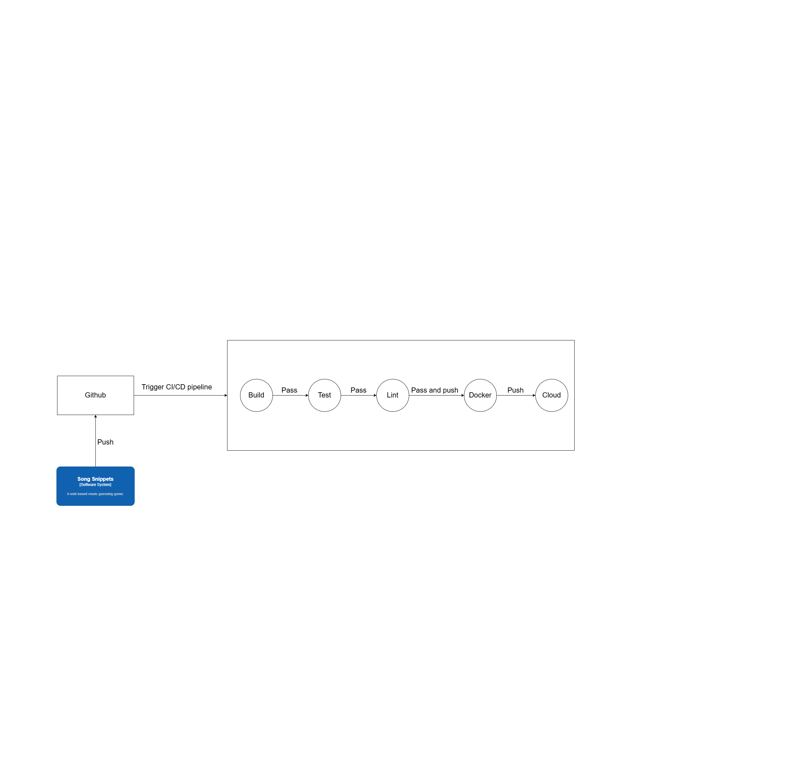

The repository for this project is on GitHub, and I’m using GitHub Actions for the CI/CD pipeline. The CI/CD pipeline is triggered when changes are pushed to the GitHub repository, regardless of the branch. It builds the project and checks for any issues. After that, it runs the existing unit tests to determine how many functionalities are covered. Once these tests pass, it lints the project to identify any code issues, code smells, and adherence to best practices. If all checks are successful, it pushes the build to Docker and then deploys it to the cloud.